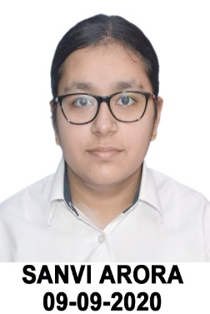

**SANVI ARORA**

Student -2nd Year, Bachelor of Engineering(Computer Science and Engineering), Thapar Institute of Engineering and Technology, Patiala, India

**Mob No.**: 9310213406

**Email**: [arorasanvi95@gmail.co](mailto:arorasanvi95@gmail.co)m

# **Objective**

# To succeed in the professional practice of engineering and apply my knowledge of science, mathematics to analyze and interpret data.

# Apply my skills in the field of study of growth and excellence along with job satisfaction and working towards achieving organizational goals.

### Education

|  |  |  |  |  |  |  |  |  |
| --- | --- | --- | --- | --- | --- | --- | --- | --- |
| |  | | --- | | * 2nd Year, Bachelor of Engineering(Computer Science and Engineering), Thapar Institute of Engineering and Technology, Patiala, India , 2022-2023 | | * 1st Year,BE(Computer Science and Engineering), Thapar Institute of Engineering and Technology, Patiala, India, CGPA 8.7 , 2021-2022 | | * 12th CBSE, Bharat Ram Global School, Greater Noida   96.4 % Overall Marks, 2020-2021 | | * 10th CBSE, GD Goenka Public School, Greater Noida   96.4 % Overall Marks, 2018-2019 | |  |  |  |  |
|  |  |  |  |  |
|  |  |  |  |  |

**Skills & Abilities**

|  |  |  |
| --- | --- | --- |
| * C++ * Android App Development * Learning Python * Team Work * Group Leading * Good Communication Skills * Goal Oriented |  |  |

### PROJECTS

1. Quiz App
2. Weather App
3. Calculator
4. Books App

### Certificates

|  |  |  |
| --- | --- | --- |
| Android App Development | 8 week Online Training, 15-07 2022,  CERTIFICATE NO. 850F13B3-B974-515A-5902-A596018C531F | Internshala Trainings |
| Python and Deep Learning | 7 days Bootcamp | Devtown, in collaboration with Microsoft Learn |
|  |  |  |
|  |  |  |
|  |  |  |
|  |  |  |

ACHIEVEMENTS

* 100% Fees Scholarship holder for Class XI and Class XII based on excellent academic achievements in preceding years respectively as per school policy
* Winner for English Debate Competition , Class XII
* One of the school toppers in class X
* Academic achievement Awards from Class V to IX in ISWK, Muscat, Oman